2001:cbf0::/32

Toledo 2001:cbf0::/48

Napoleon 2001:cbf0:1::/48

Port Clinton 2001:cbf0:2::/48

Toledo to Napoleon 2001:cbf0:3::/48

Toledo to Port Clinton 2001:cbf0:4::/48

Napoleon to Port Clinton 2001:cbf0:5::/48

Toledo PC 2001:cbf0::1:1/48

Napoleon PC 2001:cbf0:2::1:1/48

Port Clinton PC 2001:cbf0:1::1:1/48

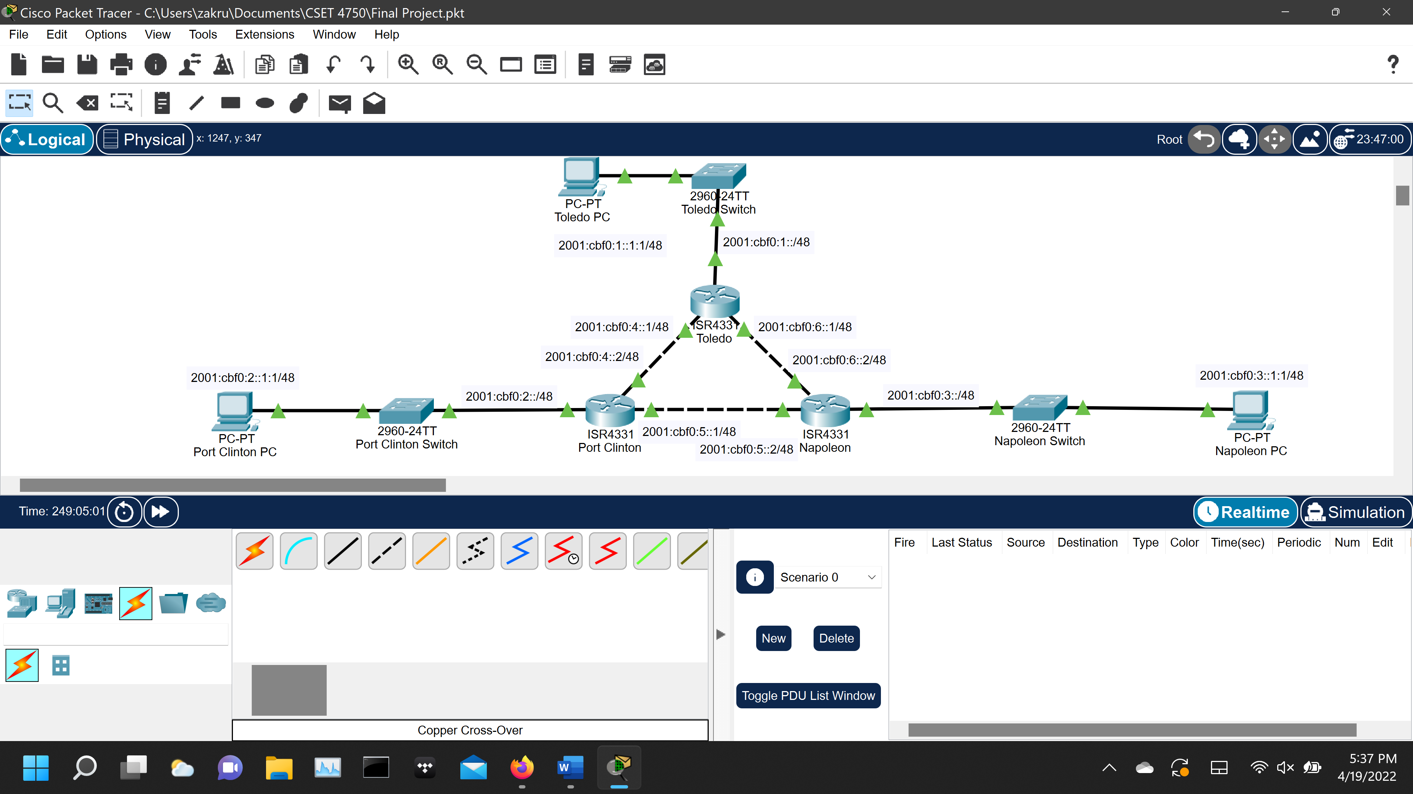

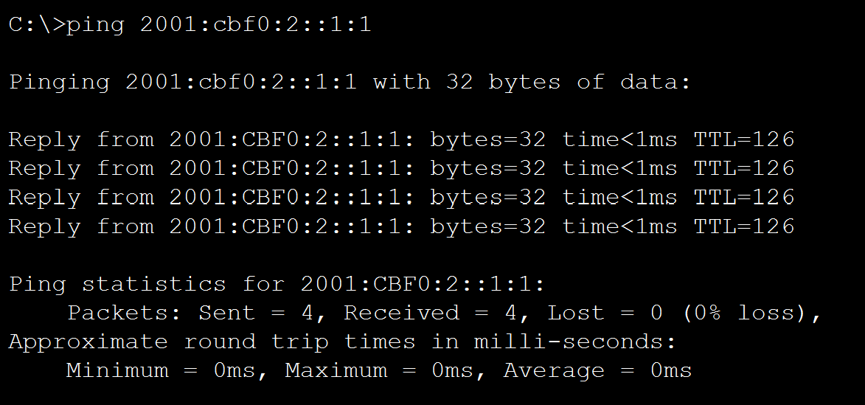

Toledo(config)#ipv6 route 2001:cbf0:2::/48 2001:cbf0:4::2

Toledo(config)#ipv6 route 2001:cbf0:3::/48 2001:cbf0:6::2

PortClinton(config)#ipv6 route 2001:cbf0:1::/48 2001:cbf0:4::1

PortClinton(config)#ipv6 route 2001:cbf0:3::/48 2001:cbf0:5::2

Napoleon(config)#ipv6 route 2001:cbf0:1::/48 2001:cbf0:6::1

Napoleon(config)#ipv6 route 2001:cbf0:2::/48 2001:cbf0:5::1

Toledo#show ipv6 route

IPv6 Routing Table - 10 entries

Codes: C - Connected, L - Local, S - Static, R - RIP, B - BGP

U - Per-user Static route, M - MIPv6

I1 - ISIS L1, I2 - ISIS L2, IA - ISIS interarea, IS - ISIS summary

ND - ND Default, NDp - ND Prefix, DCE - Destination, NDr - Redirect

O - OSPF intra, OI - OSPF inter, OE1 - OSPF ext 1, OE2 - OSPF ext 2

ON1 - OSPF NSSA ext 1, ON2 - OSPF NSSA ext 2

D - EIGRP, EX - EIGRP external

C 2001:CBF0:1::/48 [0/0]

via GigabitEthernet0/0/0, directly connected

L 2001:CBF0:1::/128 [0/0]

via GigabitEthernet0/0/0, receive

S 2001:CBF0:2::/48 [1/0]

via 2001:CBF0:4::2

C 2001:CBF0:3::/48 [0/0]

via GigabitEthernet0/0/2, directly connected

L 2001:CBF0:3::1/128 [0/0]

via GigabitEthernet0/0/2, receive

C 2001:CBF0:4::/48 [0/0]

via GigabitEthernet0/0/1, directly connected

L 2001:CBF0:4::1/128 [0/0]

via GigabitEthernet0/0/1, receive

R 2001:CBF0:5::/48 [120/2]

via FE80::230:F2FF:FEE1:C002, GigabitEthernet0/0/1

via FE80::203:E4FF:FE02:4E02, GigabitEthernet0/0/2

R 2001:CBF0:6::/48 [120/2]

via FE80::203:E4FF:FE02:4E02, GigabitEthernet0/0/2

L FF00::/8 [0/0]

via Null0, receive

PortClinton#show ipv6 route

IPv6 Routing Table - 11 entries

Codes: C - Connected, L - Local, S - Static, R - RIP, B - BGP

U - Per-user Static route, M - MIPv6

I1 - ISIS L1, I2 - ISIS L2, IA - ISIS interarea, IS - ISIS summary

ND - ND Default, NDp - ND Prefix, DCE - Destination, NDr - Redirect

O - OSPF intra, OI - OSPF inter, OE1 - OSPF ext 1, OE2 - OSPF ext 2

ON1 - OSPF NSSA ext 1, ON2 - OSPF NSSA ext 2

D - EIGRP, EX - EIGRP external

S 2001:CBF0::/48 [1/0]

via 2001:CBF0:4::1

S 2001:CBF0:1::/48 [1/0]

via 2001:CBF0:4::1

C 2001:CBF0:2::/48 [0/0]

via GigabitEthernet0/0/0, directly connected

L 2001:CBF0:2::/128 [0/0]

via GigabitEthernet0/0/0, receive

S 2001:CBF0:3::/48 [1/0]

via 2001:CBF0:5::2

C 2001:CBF0:4::/48 [0/0]

via GigabitEthernet0/0/1, directly connected

L 2001:CBF0:4::2/128 [0/0]

via GigabitEthernet0/0/1, receive

C 2001:CBF0:5::/48 [0/0]

via GigabitEthernet0/0/2, directly connected

L 2001:CBF0:5::1/128 [0/0]

via GigabitEthernet0/0/2, receive

R 2001:CBF0:6::/48 [120/2]

via FE80::203:E4FF:FE02:4E03, GigabitEthernet0/0/2

L FF00::/8 [0/0]

via Null0, receive

Napoleon#show ipv6 route

IPv6 Routing Table - 10 entries

Codes: C - Connected, L - Local, S - Static, R - RIP, B - BGP

U - Per-user Static route, M - MIPv6

I1 - ISIS L1, I2 - ISIS L2, IA - ISIS interarea, IS - ISIS summary

ND - ND Default, NDp - ND Prefix, DCE - Destination, NDr - Redirect

O - OSPF intra, OI - OSPF inter, OE1 - OSPF ext 1, OE2 - OSPF ext 2

ON1 - OSPF NSSA ext 1, ON2 - OSPF NSSA ext 2

D - EIGRP, EX - EIGRP external

S 2001:CBF0:1::/48 [1/0]

via 2001:CBF0:6::1

S 2001:CBF0:2::/48 [1/0]

via 2001:CBF0:5::1

C 2001:CBF0:3::/48 [0/0]

via GigabitEthernet0/0/0, directly connected

L 2001:CBF0:3::/128 [0/0]

via GigabitEthernet0/0/0, receive

R 2001:CBF0:4::/48 [120/2]

via FE80::230:F2FF:FEE1:C003, GigabitEthernet0/0/2

via FE80::201:63FF:FE86:EA03, GigabitEthernet0/0/1

C 2001:CBF0:5::/48 [0/0]

via GigabitEthernet0/0/2, directly connected

L 2001:CBF0:5::2/128 [0/0]

via GigabitEthernet0/0/2, receive

C 2001:CBF0:6::/48 [0/0]

via GigabitEthernet0/0/1, directly connected

L 2001:CBF0:6::2/128 [0/0]

via GigabitEthernet0/0/1, receive

L FF00::/8 [0/0]

via Null0, receive

Toledo#show running-config

Building configuration...

Current configuration : 1100 bytes

!

version 16.6.4

no service timestamps log datetime msec

no service timestamps debug datetime msec

no service password-encryption

!

hostname Toledo

!

!

!

!

!

!

!

!

no ip cef

ipv6 unicast-routing

!

no ipv6 cef

!

!

!

!

!

!

!

!

!

!

!

!

spanning-tree mode pvst

!

!

!

!

!

!

interface GigabitEthernet0/0/0

no ip address

duplex auto

speed auto

ipv6 address 2001:CBF0:1::/48

ipv6 enable

!

interface GigabitEthernet0/0/1

no ip address

duplex auto

speed auto

ipv6 address 2001:CBF0:4::1/48

ipv6 enable

!

interface GigabitEthernet0/0/2

no ip address

duplex auto

speed auto

ipv6 address 2001:CBF0:3::1/48

ipv6 enable

!

interface Vlan1

no ip address

shutdown

!

router rip

!

!

ip classless

!

ip flow-export version 9

!

ipv6 route 2001:CBF0:2::/48 2001:CBF0:4::2

ipv6 route 2001:CBF0:1::/48 2001:CBF0:4::2

ipv6 route 2001:CBF0:4::/48 2001:CBF0:4::2

ipv6 route 2001:CBF0:3::/48 2001:CBF0:6::2

!

!

!

!

!

!

!

line con 0

!

line aux 0

!

line vty 0 4

login

!

!

!

end

PortClinton#show running-config

Building configuration...

Current configuration : 1114 bytes

!

version 16.6.4

no service timestamps log datetime msec

no service timestamps debug datetime msec

no service password-encryption

!

hostname PortClinton

!

!

!

!

!

!

!

!

no ip cef

ipv6 unicast-routing

!

no ipv6 cef

!

!

!

!

!

!

!

!

!

!

!

!

spanning-tree mode pvst

!

!

!

!

!

!

interface GigabitEthernet0/0/0

no ip address

duplex auto

speed auto

ipv6 address 2001:CBF0:2::/48

ipv6 enable

!

interface GigabitEthernet0/0/1

no ip address

duplex auto

speed auto

ipv6 address 2001:CBF0:4::2/48

ipv6 enable

!

interface GigabitEthernet0/0/2

no ip address

duplex auto

speed auto

ipv6 address 2001:CBF0:5::1/48

ipv6 enable

!

interface Vlan1

no ip address

shutdown

!

!

ip classless

!

ip flow-export version 9

!

ipv6 route 2001:CBF0:4::/48 GigabitEthernet0/0/1

ipv6 route 2001:CBF0::/48 2001:CBF0:4::1

ipv6 route 2001:CBF0:4::/48 2001:CBF0:4::1

ipv6 route 2001:CBF0:1::/48 2001:CBF0:4::1

ipv6 route 2001:CBF0:3::/48 2001:CBF0:5::2

!

!

!

!

!

!

!

line con 0

!

line aux 0

!

line vty 0 4

login

!

!

!

end

Napoleon#show running-config

Building configuration...

Current configuration : 978 bytes

!

version 16.6.4

no service timestamps log datetime msec

no service timestamps debug datetime msec

no service password-encryption

!

hostname Napoleon

!

!

!

!

!

!

!

!

no ip cef

ipv6 unicast-routing

!

no ipv6 cef

!

!

!

!

!

!

!

!

!

!

!

!

spanning-tree mode pvst

!

!

!

!

!

!

interface GigabitEthernet0/0/0

no ip address

duplex auto

speed auto

ipv6 address 2001:CBF0:3::/48

ipv6 enable

!

interface GigabitEthernet0/0/1

no ip address

duplex auto

speed auto

ipv6 address 2001:CBF0:6::2/48

ipv6 enable

!

interface GigabitEthernet0/0/2

no ip address

duplex auto

speed auto

ipv6 address 2001:CBF0:5::2/48

ipv6 enable

!

interface Vlan1

no ip address

shutdown

!

!

ip classless

!

ip flow-export version 9

!

ipv6 route 2001:CBF0:2::/48 2001:CBF0:5::1

ipv6 route 2001:CBF0:1::/48 2001:CBF0:6::1

!

!

!

!

!

!

!

line con 0

!

line aux 0

!

line vty 0 4

login

!

!

!

end

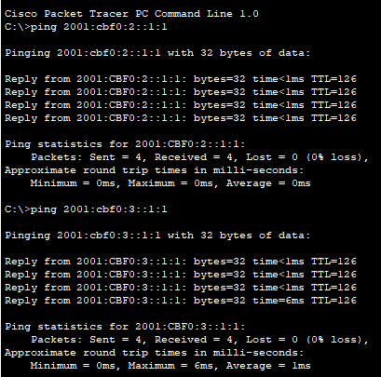

Toledo(config)#ipv6 router rip Toledo

Toledo(config-rtr)#int GigabitEthernet0/0/0

Toledo(config-if)#ipv6 rip Toledo enable

Toledo(config-if)#int GigabitEthernet0/0/1

Toledo(config-if)#ipv6 rip Toledo enable

Toledo(config-if)#int GigabitEthernet0/0/2

Toledo(config-if)#ipv6 rip Toledo enable

PortClinton(config)#ipv6 router rip Toledo

PortClinton(config-rtr)#int GigabitEthernet0/0/0

PortClinton(config-if)#ipv6 rip Toledo enable

PortClinton(config-if)#int GigabitEthernet0/0/1

PortClinton(config-if)#ipv6 rip Toledo enable

PortClinton(config-if)#int GigabitEthernet0/0/2

PortClinton(config-if)#ipv6 rip Toledo enable

Napoleon(config)#ipv6 router rip Toledo

Napoleon(config-rtr)#int GigabitEthernet0/0/0

Napoleon(config-if)#ipv6 rip Toledo enable

Napoleon(config-if)#int GigabitEthernet0/0/1

Napoleon(config-if)#ipv6 rip Toledo enable

Napoleon(config-if)#int GigabitEthernet0/0/2

Napoleon(config-if)#ipv6 rip Toledo enable

Toledo#show ipv6 route

IPv6 Routing Table - 10 entries

Codes: C - Connected, L - Local, S - Static, R - RIP, B - BGP

U - Per-user Static route, M - MIPv6

I1 - ISIS L1, I2 - ISIS L2, IA - ISIS interarea, IS - ISIS summary

ND - ND Default, NDp - ND Prefix, DCE - Destination, NDr - Redirect

O - OSPF intra, OI - OSPF inter, OE1 - OSPF ext 1, OE2 - OSPF ext 2

ON1 - OSPF NSSA ext 1, ON2 - OSPF NSSA ext 2

D - EIGRP, EX - EIGRP external

C 2001:CBF0:1::/48 [0/0]

via GigabitEthernet0/0/0, directly connected

L 2001:CBF0:1::/128 [0/0]

via GigabitEthernet0/0/0, receive

R 2001:CBF0:2::/48 [120/2]

via FE80::201:43FF:FE0D:7003, GigabitEthernet0/0/1

R 2001:CBF0:3::/48 [120/2]

via FE80::250:FFF:FE73:502, GigabitEthernet0/0/2

C 2001:CBF0:4::/48 [0/0]

via GigabitEthernet0/0/1, directly connected

L 2001:CBF0:4::1/128 [0/0]

via GigabitEthernet0/0/1, receive

R 2001:CBF0:5::/48 [120/2]

via FE80::201:43FF:FE0D:7003, GigabitEthernet0/0/1

via FE80::250:FFF:FE73:502, GigabitEthernet0/0/2

C 2001:CBF0:6::/48 [0/0]

via GigabitEthernet0/0/2, directly connected

L 2001:CBF0:6::1/128 [0/0]

via GigabitEthernet0/0/2, receive

L FF00::/8 [0/0]

via Null0, receive

PortClinton#show ipv6 route

IPv6 Routing Table - 10 entries

Codes: C - Connected, L - Local, S - Static, R - RIP, B - BGP

U - Per-user Static route, M - MIPv6

I1 - ISIS L1, I2 - ISIS L2, IA - ISIS interarea, IS - ISIS summary

ND - ND Default, NDp - ND Prefix, DCE - Destination, NDr - Redirect

O - OSPF intra, OI - OSPF inter, OE1 - OSPF ext 1, OE2 - OSPF ext 2

ON1 - OSPF NSSA ext 1, ON2 - OSPF NSSA ext 2

D - EIGRP, EX - EIGRP external

R 2001:CBF0:1::/48 [120/2]

via FE80::2D0:97FF:FE5D:5002, GigabitEthernet0/0/2

C 2001:CBF0:2::/48 [0/0]

via GigabitEthernet0/0/0, directly connected

L 2001:CBF0:2::/128 [0/0]

via GigabitEthernet0/0/0, receive

R 2001:CBF0:3::/48 [120/2]

via FE80::250:FFF:FE73:503, GigabitEthernet0/0/1

C 2001:CBF0:4::/48 [0/0]

via GigabitEthernet0/0/2, directly connected

L 2001:CBF0:4::2/128 [0/0]

via GigabitEthernet0/0/2, receive

C 2001:CBF0:5::/48 [0/0]

via GigabitEthernet0/0/1, directly connected

L 2001:CBF0:5::1/128 [0/0]

via GigabitEthernet0/0/1, receive

R 2001:CBF0:6::/48 [120/2]

via FE80::2D0:97FF:FE5D:5002, GigabitEthernet0/0/2

via FE80::250:FFF:FE73:503, GigabitEthernet0/0/1

L FF00::/8 [0/0]

via Null0, receive

Napoleon#show ipv6 route

IPv6 Routing Table - 10 entries

Codes: C - Connected, L - Local, S - Static, R - RIP, B - BGP

U - Per-user Static route, M - MIPv6

I1 - ISIS L1, I2 - ISIS L2, IA - ISIS interarea, IS - ISIS summary

ND - ND Default, NDp - ND Prefix, DCE - Destination, NDr - Redirect

O - OSPF intra, OI - OSPF inter, OE1 - OSPF ext 1, OE2 - OSPF ext 2

ON1 - OSPF NSSA ext 1, ON2 - OSPF NSSA ext 2

D - EIGRP, EX - EIGRP external

R 2001:CBF0:1::/48 [120/2]

via FE80::2D0:97FF:FE5D:5003, GigabitEthernet0/0/1

R 2001:CBF0:2::/48 [120/2]

via FE80::201:43FF:FE0D:7002, GigabitEthernet0/0/2

C 2001:CBF0:3::/48 [0/0]

via GigabitEthernet0/0/0, directly connected

L 2001:CBF0:3::/128 [0/0]

via GigabitEthernet0/0/0, receive

R 2001:CBF0:4::/48 [120/2]

via FE80::2D0:97FF:FE5D:5003, GigabitEthernet0/0/1

via FE80::201:43FF:FE0D:7002, GigabitEthernet0/0/2

C 2001:CBF0:5::/48 [0/0]

via GigabitEthernet0/0/2, directly connected

L 2001:CBF0:5::2/128 [0/0]

via GigabitEthernet0/0/2, receive

C 2001:CBF0:6::/48 [0/0]

via GigabitEthernet0/0/1, directly connected

L 2001:CBF0:6::2/128 [0/0]

via GigabitEthernet0/0/1, receive

L FF00::/8 [0/0]

via Null0, receive

Toledo#show running-config

Building configuration...

Current configuration : 891 bytes

!

version 16.6.4

no service timestamps log datetime msec

no service timestamps debug datetime msec

no service password-encryption

!

hostname Toledo

!

!

!

!

!

!

!

!

no ip cef

ipv6 unicast-routing

!

no ipv6 cef

!

!

!

!

!

!

!

!

!

!

!

!

spanning-tree mode pvst

!

!

!

!

!

!

interface GigabitEthernet0/0/0

no ip address

duplex auto

speed auto

ipv6 address 2001:CBF0:1::/48

ipv6 rip Toledo enable

ipv6 enable

!

interface GigabitEthernet0/0/1

no ip address

duplex auto

speed auto

ipv6 address 2001:CBF0:4::1/48

ipv6 rip Toledo enable

ipv6 enable

!

interface GigabitEthernet0/0/2

no ip address

duplex auto

speed auto

ipv6 address 2001:CBF0:6::1/48

ipv6 rip Toledo enable

ipv6 enable

!

interface Vlan1

no ip address

shutdown

!

router rip

!

ipv6 router rip Toledo

!

ip classless

!

ip flow-export version 9

!

!

!

!

!

!

!

!

line con 0

!

line aux 0

!

line vty 0 4

login

!

!

!

end

PortClinton#show running-config

Building configuration...

Current configuration : 880 bytes

!

version 16.6.4

no service timestamps log datetime msec

no service timestamps debug datetime msec

no service password-encryption

!

hostname PortClinton

!

!

!

!

!

!

!

!

ip cef

ipv6 unicast-routing

!

no ipv6 cef

!

!

!

!

!

!

!

!

!

!

!

!

spanning-tree mode pvst

!

!

!

!

!

!

interface GigabitEthernet0/0/0

no ip address

duplex auto

speed auto

ipv6 address 2001:CBF0:2::/48

ipv6 rip Toledo enable

ipv6 enable

!

interface GigabitEthernet0/0/1

no ip address

duplex auto

speed auto

ipv6 address 2001:CBF0:5::1/48

ipv6 rip Toledo enable

ipv6 enable

!

interface GigabitEthernet0/0/2

no ip address

duplex auto

speed auto

ipv6 address 2001:CBF0:4::2/48

ipv6 rip Toledo enable

ipv6 enable

!

interface Vlan1

no ip address

shutdown

!

ipv6 router rip Toledo

!

ip classless

!

ip flow-export version 9

!

!

!

!

!

!

!

!

line con 0

!

line aux 0

!

line vty 0 4

login

!

!

!

end

Napoleon#show running-config

Building configuration...

Current configuration : 877 bytes

!

version 16.6.4

no service timestamps log datetime msec

no service timestamps debug datetime msec

no service password-encryption

!

hostname Napoleon

!

!

!

!

!

!

!

!

ip cef

ipv6 unicast-routing

!

no ipv6 cef

!

!

!

!

!

!

!

!

!

!

!

!

spanning-tree mode pvst

!

!

!

!

!

!

interface GigabitEthernet0/0/0

no ip address

duplex auto

speed auto

ipv6 address 2001:CBF0:3::/48

ipv6 rip Toledo enable

ipv6 enable

!

interface GigabitEthernet0/0/1

no ip address

duplex auto

speed auto

ipv6 address 2001:CBF0:6::2/48

ipv6 rip Toledo enable

ipv6 enable

!

interface GigabitEthernet0/0/2

no ip address

duplex auto

speed auto

ipv6 address 2001:CBF0:5::2/48

ipv6 rip Toledo enable

ipv6 enable

!

interface Vlan1

no ip address

shutdown

!

ipv6 router rip Toledo

!

ip classless

!

ip flow-export version 9

!

!

!

!

!

!

!

!

line con 0

!

line aux 0

!

line vty 0 4

login

!

!

!

end

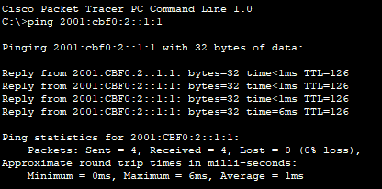

Toledo(config)#ipv6 router ospf ?

<1-65535> Process ID

Toledo(config)#ipv6 router ospf 1

%OSPFv3-4-NORTRID: OSPFv3 process 1 could not pick a router-id,please configure manually

Toledo(config-rtr)#?

area OSPF area parameters

auto-cost Calculate OSPF interface cost according to bandwidth

default-information Distribution of default information

distance Administrative distance

exit Exit from routing protocol configuration mode

log-adjacency-changes Log changes in adjacency state

no Negate a command or set its defaults

passive-interface Suppress routing updates on an interface

redistribute Redistribute information from another routing protocol

router-id router-id for this OSPF process

Toledo(config-rtr)#router-id ?

A.B.C.D OSPF router-id in IP address format

Toledo(config-rtr)#router-id 1.1.1.1

Toledo(config-rtr)#exit

Toledo(config)#do sh ip int br

Interface IP-Address OK? Method Status Protocol

GigabitEthernet0/0/0 unassigned YES unset up up

GigabitEthernet0/0/1 unassigned YES unset up up

GigabitEthernet0/0/2 unassigned YES unset up up

Vlan1 unassigned YES unset administratively down down

Toledo(config)#do sh ipv6 int br

GigabitEthernet0/0/0 [up/up]

FE80::290:CFF:FE92:E901

2001:CBF0:1::

GigabitEthernet0/0/1 [up/up]

FE80::290:CFF:FE92:E902

2001:CBF0:4::1

GigabitEthernet0/0/2 [up/up]

FE80::290:CFF:FE92:E903

2001:CBF0:6::1

Vlan1 [administratively down/down]

unassigned

Toledo(config)#interface GigabitEthernet0/0/0

Toledo(config-if)#ipv6 ?

address Configure IPv6 address on interface

authentication authentication subcommands

dhcp IPv6 DHCP interface subcommands

eigrp Configure EIGRP IPv6 on interface

enable Enable IPv6 on interface

flow NetFlow Related commands

hello-interval Configures IP-EIGRP hello interval

inspect Apply inspect name

mtu Set IPv6 Maximum Transmission Unit

nat Enable IPv6 NAT on interface

nd IPv6 interface Neighbor Discovery subcommands

ospf OSPF interface commands

rip Configure RIP routing protocol

summary-address Summary prefix

traffic-filter Access control list for packets

unnumbered Preferred interface for source address selection

Toledo(config-if)#ipv6 ospf ?

<1-65535> Process ID

cost Interface cost

dead-interval Interval after which a neighbor is declared dead

hello-interval Time between HELLO packets

neighbor OSPF neighbor

network Network type

priority Router priority

Toledo(config-if)#ipv6 ospf 1 area 0

Toledo(config-if)#int GigabitEthernet0/0/1

Toledo(config-if)#ipv6 ospf 1 area 0

Toledo(config-if)#int GigabitEthernet0/0/2

Toledo(config-if)#ipv6 ospf 1 area 0

Toledo#show ipv6 route

IPv6 Routing Table - 8 entries

Codes: C - Connected, L - Local, S - Static, R - RIP, B - BGP

U - Per-user Static route, M - MIPv6

I1 - ISIS L1, I2 - ISIS L2, IA - ISIS interarea, IS - ISIS summary

ND - ND Default, NDp - ND Prefix, DCE - Destination, NDr - Redirect

O - OSPF intra, OI - OSPF inter, OE1 - OSPF ext 1, OE2 - OSPF ext 2

ON1 - OSPF NSSA ext 1, ON2 - OSPF NSSA ext 2

D - EIGRP, EX - EIGRP external

C 2001:CBF0:1::/48 [0/0]

via GigabitEthernet0/0/0, directly connected

L 2001:CBF0:1::/128 [0/0]

via GigabitEthernet0/0/0, receive

O 2001:CBF0:2::/48 [110/2]

via FE80::2E0:A3FF:FEDD:3D02, GigabitEthernet0/0/1

C 2001:CBF0:4::/48 [0/0]

via GigabitEthernet0/0/1, directly connected

L 2001:CBF0:4::1/128 [0/0]

via GigabitEthernet0/0/1, receive

C 2001:CBF0:6::/48 [0/0]

via GigabitEthernet0/0/2, directly connected

L 2001:CBF0:6::1/128 [0/0]

via GigabitEthernet0/0/2, receive

L FF00::/8 [0/0]

via Null0, receive

PortClinton#show ipv6 route

IPv6 Routing Table - 8 entries

Codes: C - Connected, L - Local, S - Static, R - RIP, B - BGP

U - Per-user Static route, M - MIPv6

I1 - ISIS L1, I2 - ISIS L2, IA - ISIS interarea, IS - ISIS summary

ND - ND Default, NDp - ND Prefix, DCE - Destination, NDr - Redirect

O - OSPF intra, OI - OSPF inter, OE1 - OSPF ext 1, OE2 - OSPF ext 2

ON1 - OSPF NSSA ext 1, ON2 - OSPF NSSA ext 2

D - EIGRP, EX - EIGRP external

O 2001:CBF0:1::/48 [110/2]

via FE80::290:CFF:FE92:E902, GigabitEthernet0/0/1

C 2001:CBF0:2::/48 [0/0]

via GigabitEthernet0/0/0, directly connected

L 2001:CBF0:2::/128 [0/0]

via GigabitEthernet0/0/0, receive

C 2001:CBF0:4::/48 [0/0]

via GigabitEthernet0/0/1, directly connected

L 2001:CBF0:4::2/128 [0/0]

via GigabitEthernet0/0/1, receive

C 2001:CBF0:5::/48 [0/0]

via GigabitEthernet0/0/2, directly connected

L 2001:CBF0:5::1/128 [0/0]

via GigabitEthernet0/0/2, receive

L FF00::/8 [0/0]

via Null0, receive

Napoleon#show ipv6 route

IPv6 Routing Table - 7 entries

Codes: C - Connected, L - Local, S - Static, R - RIP, B - BGP

U - Per-user Static route, M - MIPv6

I1 - ISIS L1, I2 - ISIS L2, IA - ISIS interarea, IS - ISIS summary

ND - ND Default, NDp - ND Prefix, DCE - Destination, NDr - Redirect

O - OSPF intra, OI - OSPF inter, OE1 - OSPF ext 1, OE2 - OSPF ext 2

ON1 - OSPF NSSA ext 1, ON2 - OSPF NSSA ext 2

D - EIGRP, EX - EIGRP external

C 2001:CBF0:3::/48 [0/0]

via GigabitEthernet0/0/0, directly connected

L 2001:CBF0:3::/128 [0/0]

via GigabitEthernet0/0/0, receive

C 2001:CBF0:5::/48 [0/0]

via GigabitEthernet0/0/2, directly connected

L 2001:CBF0:5::2/128 [0/0]

via GigabitEthernet0/0/2, receive

C 2001:CBF0:6::/48 [0/0]

via GigabitEthernet0/0/1, directly connected

L 2001:CBF0:6::2/128 [0/0]

via GigabitEthernet0/0/1, receive

L FF00::/8 [0/0]

via Null0, receive

Toledo#show running-config

Building configuration...

Current configuration : 961 bytes

!

version 16.6.4

no service timestamps log datetime msec

no service timestamps debug datetime msec

no service password-encryption

!

hostname Toledo

!

!

!

!

!

!

!

!

ip cef

ipv6 unicast-routing

!

no ipv6 cef

!

!

!

!

!

!

!

!

!

!

!

!

spanning-tree mode pvst

!

!

!

!

!

!

interface GigabitEthernet0/0/0

no ip address

duplex auto

speed auto

ipv6 address 2001:CBF0:1::/48

ipv6 enable

ipv6 ospf 1 area 0

!

interface GigabitEthernet0/0/1

no ip address

duplex auto

speed auto

ipv6 address 2001:CBF0:4::1/48

ipv6 enable

ipv6 ospf 1 area 0

!

interface GigabitEthernet0/0/2

no ip address

duplex auto

speed auto

ipv6 address 2001:CBF0:6::1/48

ipv6 enable

ipv6 ospf 2 area 0

!

interface Vlan1

no ip address

shutdown

!

ipv6 router ospf 1

router-id 1.1.1.1

log-adjacency-changes

!

ipv6 router ospf 2

router-id 2.2.2.2

log-adjacency-changes

!

ip classless

!

ip flow-export version 9

!

!

!

!

!

!

!

!

line con 0

!

line aux 0

!

line vty 0 4

login

!

!

!

end

PortClinton#show running-config

Building configuration...

Current configuration : 883 bytes

!

version 16.6.4

no service timestamps log datetime msec

no service timestamps debug datetime msec

no service password-encryption

!

hostname PortClinton

!

!

!

!

!

!

!

!

ip cef

ipv6 unicast-routing

!

no ipv6 cef

!

!

!

!

!

!

!

!

!

!

!

!

spanning-tree mode pvst

!

!

!

!

!

!

interface GigabitEthernet0/0/0

no ip address

duplex auto

speed auto

ipv6 address 2001:CBF0:2::/48

ipv6 enable

ipv6 ospf 2 area 0

!

interface GigabitEthernet0/0/1

no ip address

duplex auto

speed auto

ipv6 address 2001:CBF0:4::2/48

ipv6 enable

ipv6 ospf 2 area 0

!

interface GigabitEthernet0/0/2

no ip address

duplex auto

speed auto

ipv6 address 2001:CBF0:5::1/48

ipv6 enable

!

interface Vlan1

no ip address

shutdown

!

ipv6 router ospf 2

router-id 2.2.2.2

log-adjacency-changes

!

ip classless

!

ip flow-export version 9

!

!

!

!

!

!

!

!

line con 0

!

line aux 0

!

line vty 0 4

login

!

!

!

end

Napoleon#show running-config

Building configuration...

Current configuration : 777 bytes

!

version 16.6.4

no service timestamps log datetime msec

no service timestamps debug datetime msec

no service password-encryption

!

hostname Napoleon

!

!

!

!

!

!

!

!

ip cef

ipv6 unicast-routing

!

no ipv6 cef

!

!

!

!

!

!

!

!

!

!

!

!

spanning-tree mode pvst

!

!

!

!

!

!

interface GigabitEthernet0/0/0

no ip address

duplex auto

speed auto

ipv6 address 2001:CBF0:3::/48

ipv6 enable

!

interface GigabitEthernet0/0/1

no ip address

duplex auto

speed auto

ipv6 address 2001:CBF0:6::2/48

ipv6 enable

!

interface GigabitEthernet0/0/2

no ip address

duplex auto

speed auto

ipv6 address 2001:CBF0:5::2/48

ipv6 enable

!

interface Vlan1

no ip address

shutdown

!

ip classless

!

ip flow-export version 9

!

!

!

!

!

!

!

!

line con 0

!

line aux 0

!

line vty 0 4

login

!

!

!

end

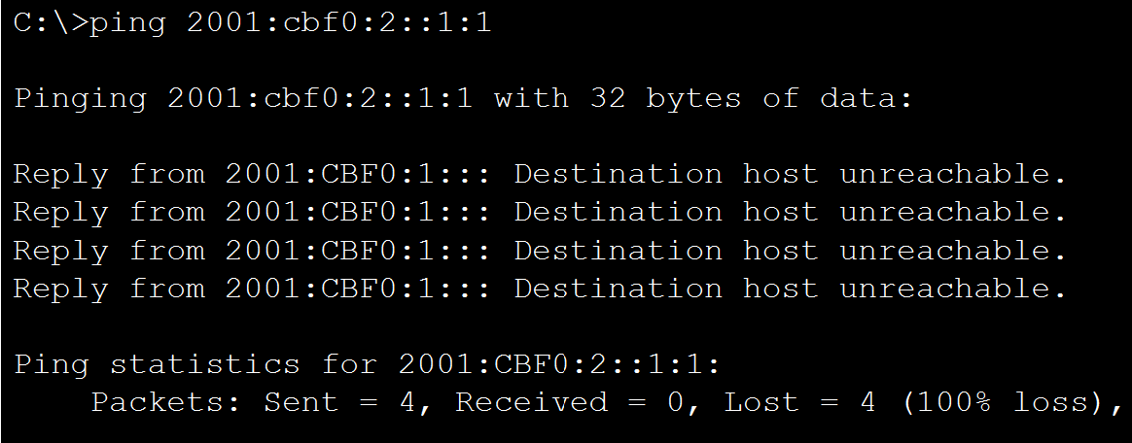

Toledo#configure terminal

Enter configuration commands, one per line. End with CNTL/Z.

Toledo(config)#interface GigabitEthernet0/0/1

Toledo(config-if)#ipv6 traffic-filter BlockICMP out

Toledo(config-if)#exit

Toledo(config)#ipv6 access-list BlockICMP

Toledo(config-ipv6-acl)#deny icmp any any

Toledo(config-ipv6-acl)#permit ipv6 any any

Toledo(config-ipv6-acl)#exit

Toledo(config)#end

Toledo#show running-config

Building configuration...

Current configuration : 1007 bytes

!

version 15.4

no service timestamps log datetime msec

no service timestamps debug datetime msec

no service password-encryption

!

hostname Toledo

!

!

!

!

!

!

!

!

no ip cef

ipv6 unicast-routing

!

no ipv6 cef

!

!

!

!

!

!

!

!

!

!

!

!

spanning-tree mode pvst

!

!

!

!

!

!

interface GigabitEthernet0/0/0

no ip address

duplex auto

speed auto

ipv6 address 2001:CBF0:1::/48

ipv6 rip Toledo enable

ipv6 enable

!

interface GigabitEthernet0/0/1

no ip address

ipv6 traffic-filter BlockICMP out

duplex auto

speed auto

ipv6 address 2001:CBF0:4::1/48

ipv6 rip Toledo enable

ipv6 enable

!

interface GigabitEthernet0/0/2

media-type sfp

no ip address

duplex auto

speed auto

ipv6 address 2001:CBF0:6::1/48

ipv6 rip Toledo enable

ipv6 enable

!

interface Vlan1

no ip address

shutdown

!

router rip

!

ipv6 router rip Toledo

!

ip classless

!

ip flow-export version 9

!

!

ipv6 access-list BlockICMP

deny icmp any any

permit ipv6 any any

!

!

!

!

!

!

line con 0

!

line aux 0

!

line vty 0 4

login

!

!

!

end